GENESIS Audio Configuration Guide with GCX-ONE

Note:
- GENESIS Audio is configurable only if the user has the required permissions

-"Local mode" settings are not required (calls can be initiated via GENESIS Audio even if the local mode is disabled)

1. Add GENESIS Audio Device
Step 1: Log in to GCX-ONE.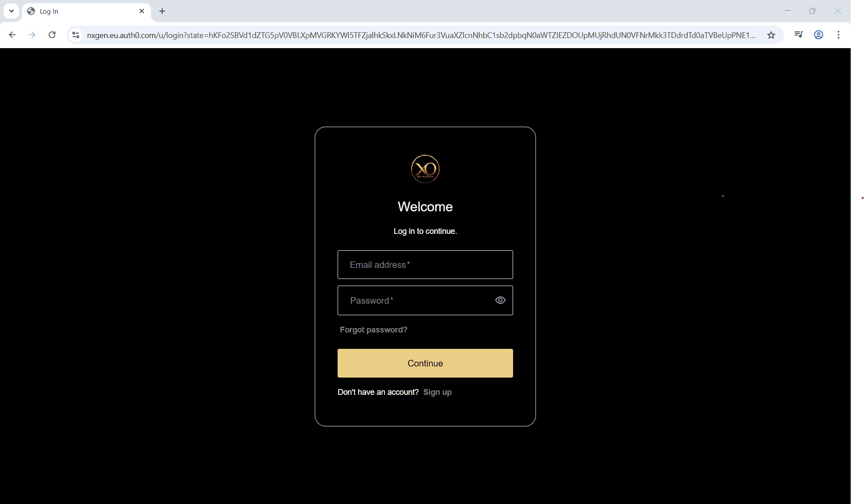
Step 2: Click the Configuration menu.

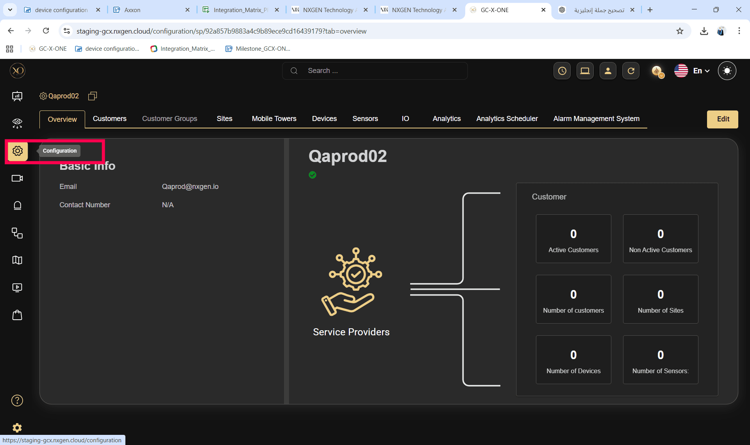

Step 3: Select the site under which the GENESIS Audio device needs to be added.
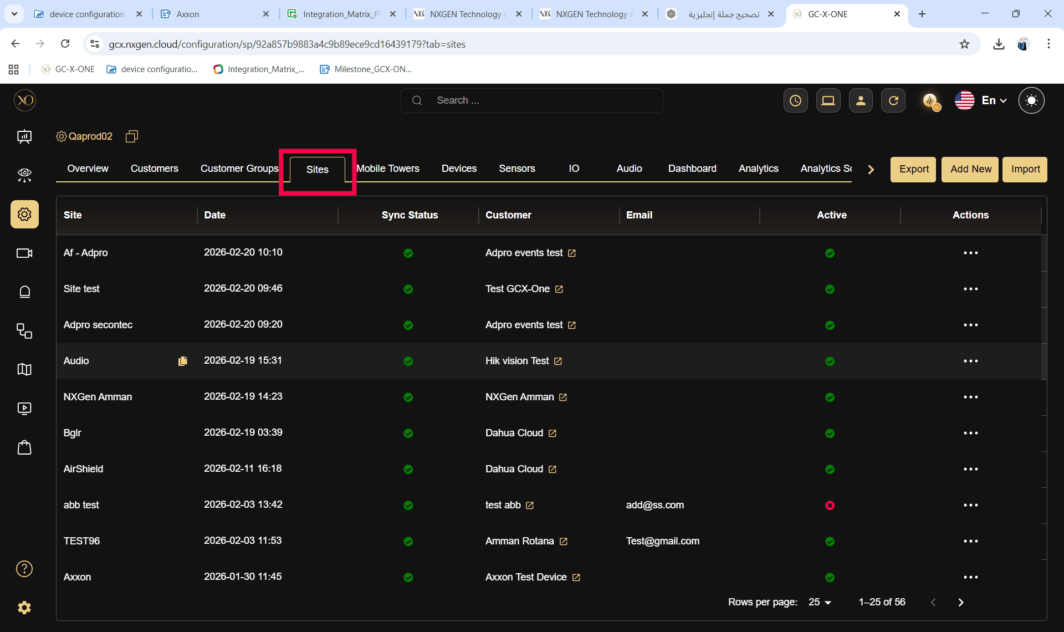

Step 4: Navigate to the Devices tab.
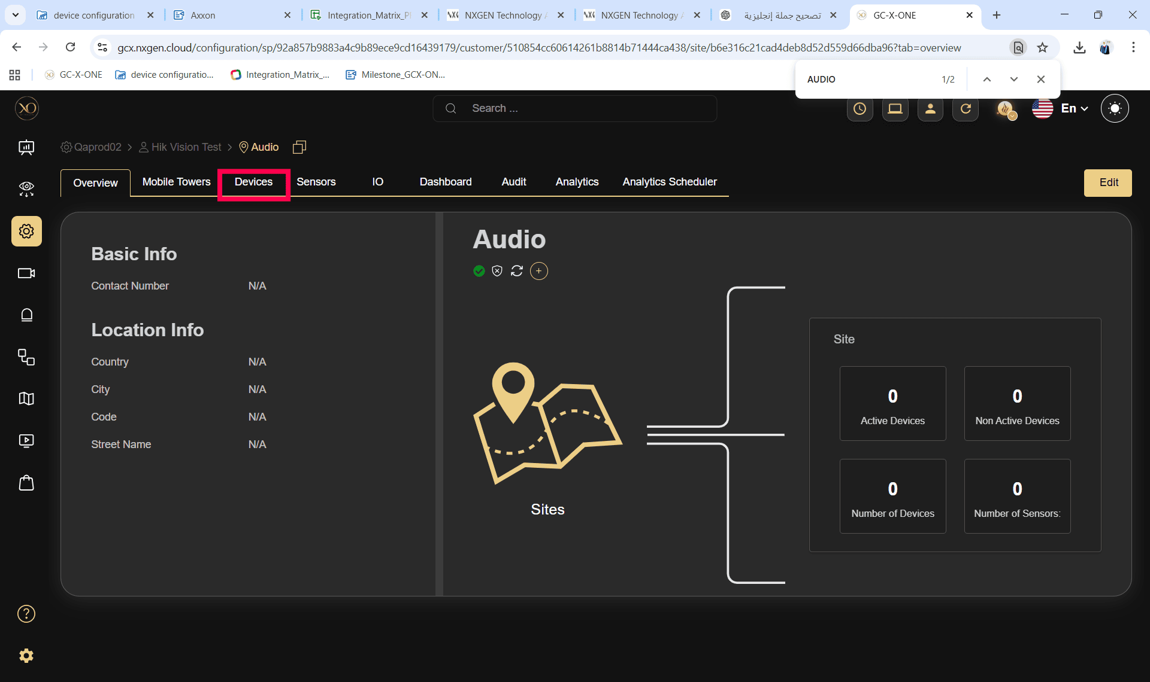

Step 5: Click the Add button.
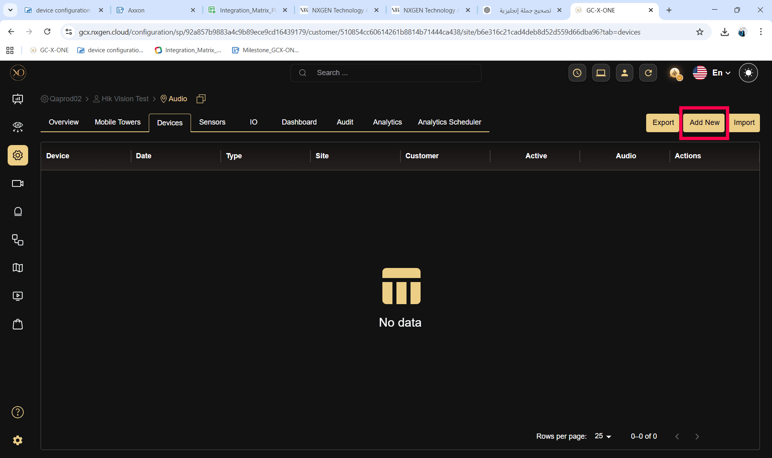

Step 6: Under General Settings, open the Type dropdown and select GENESIS Audio.
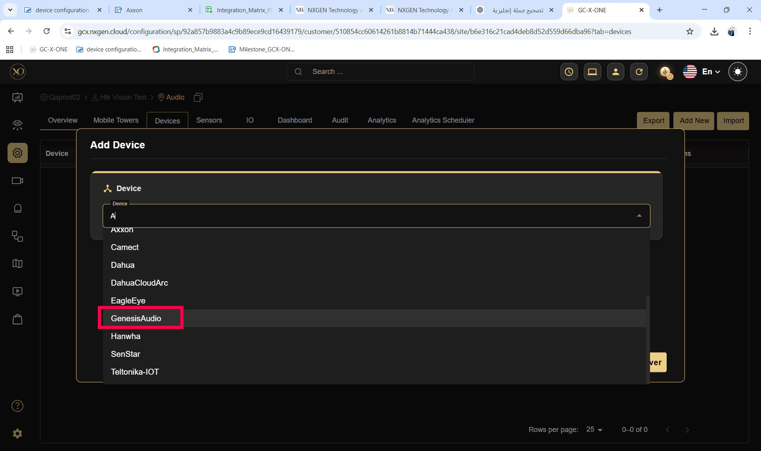
Step 7: Enter the desired Name and click Discover.
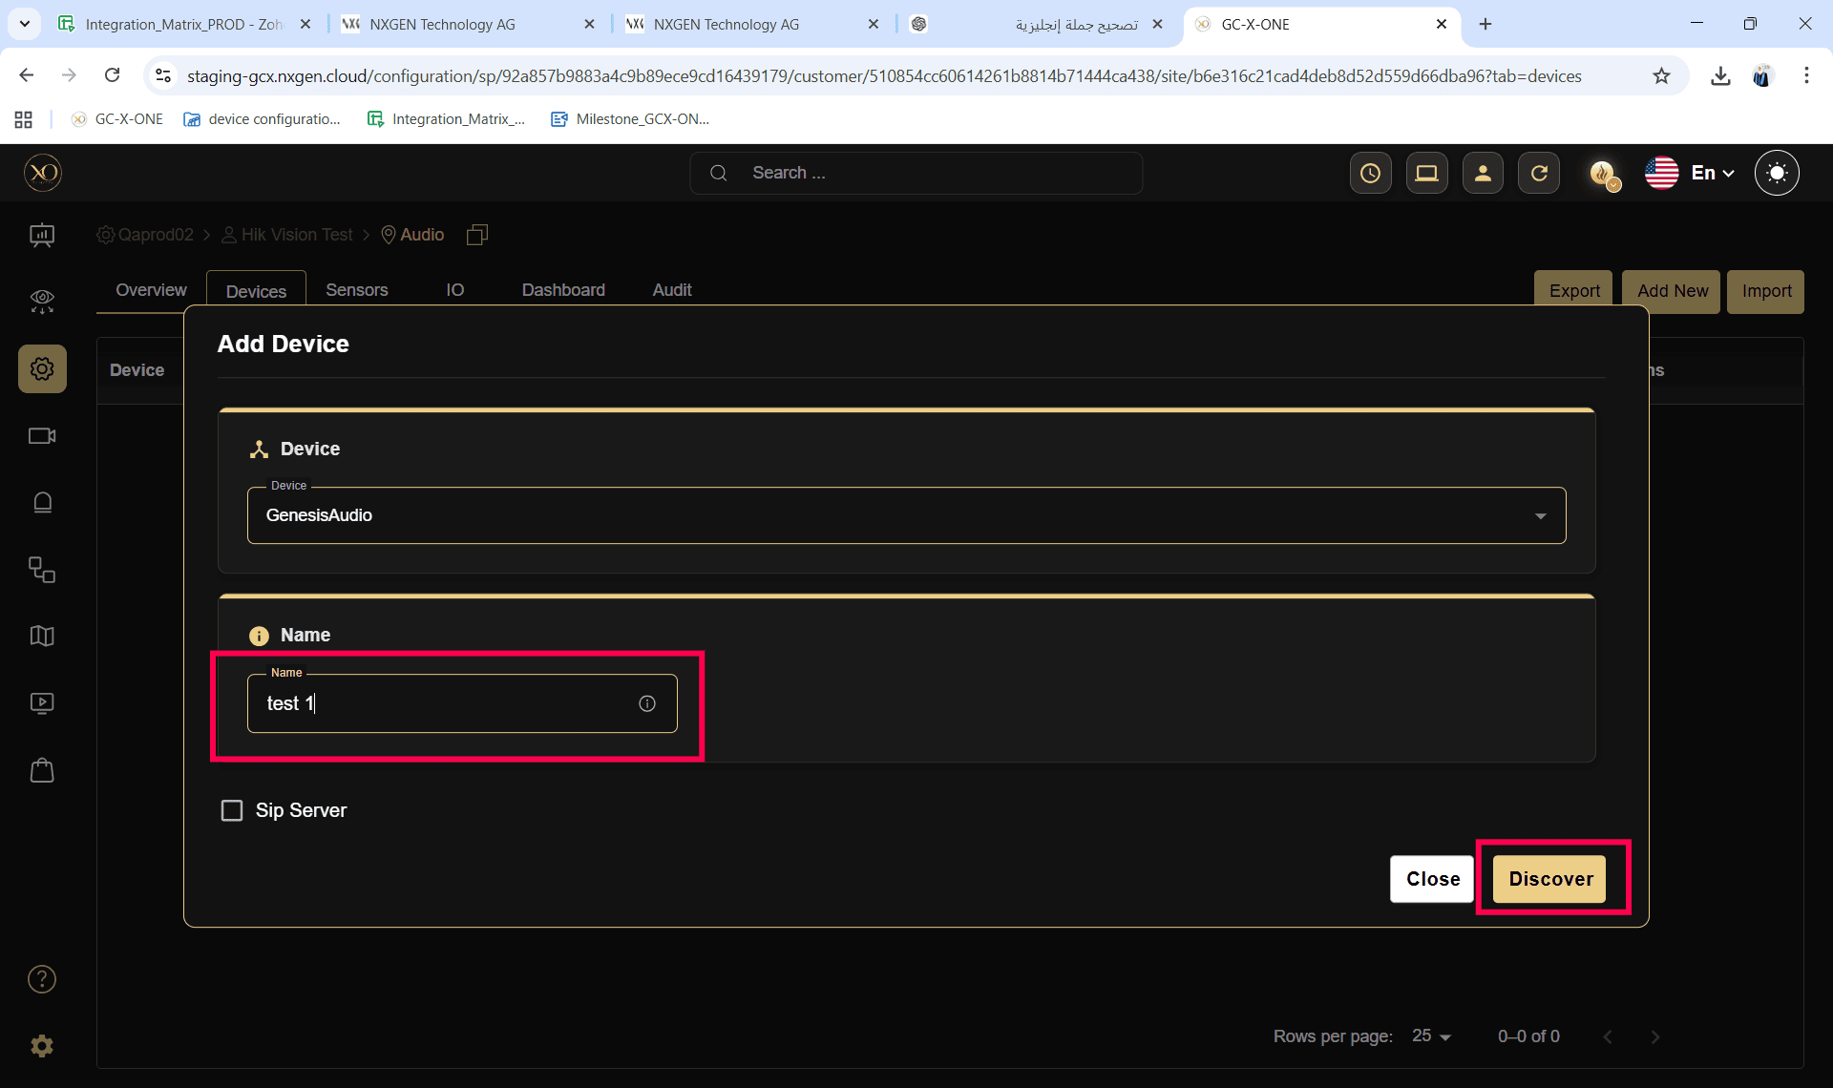

Step 8: Once the device is discovered, click Save.
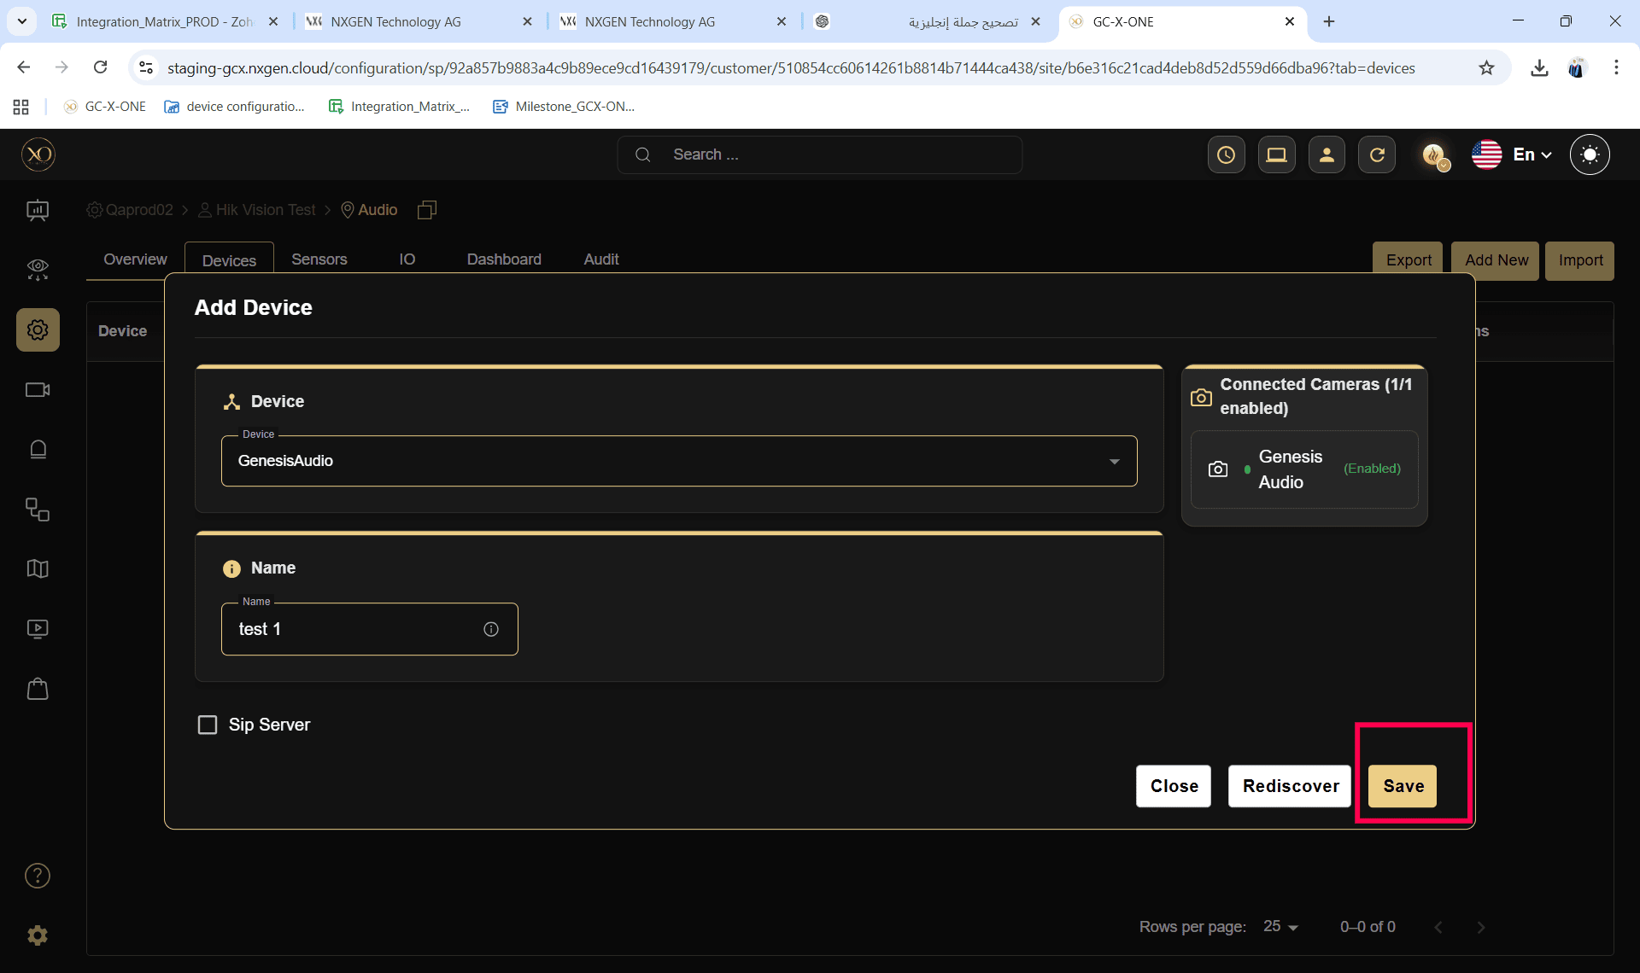
Step 9: A success message ("The device was added successfully") will be displayed, and the device will be added to the data table.
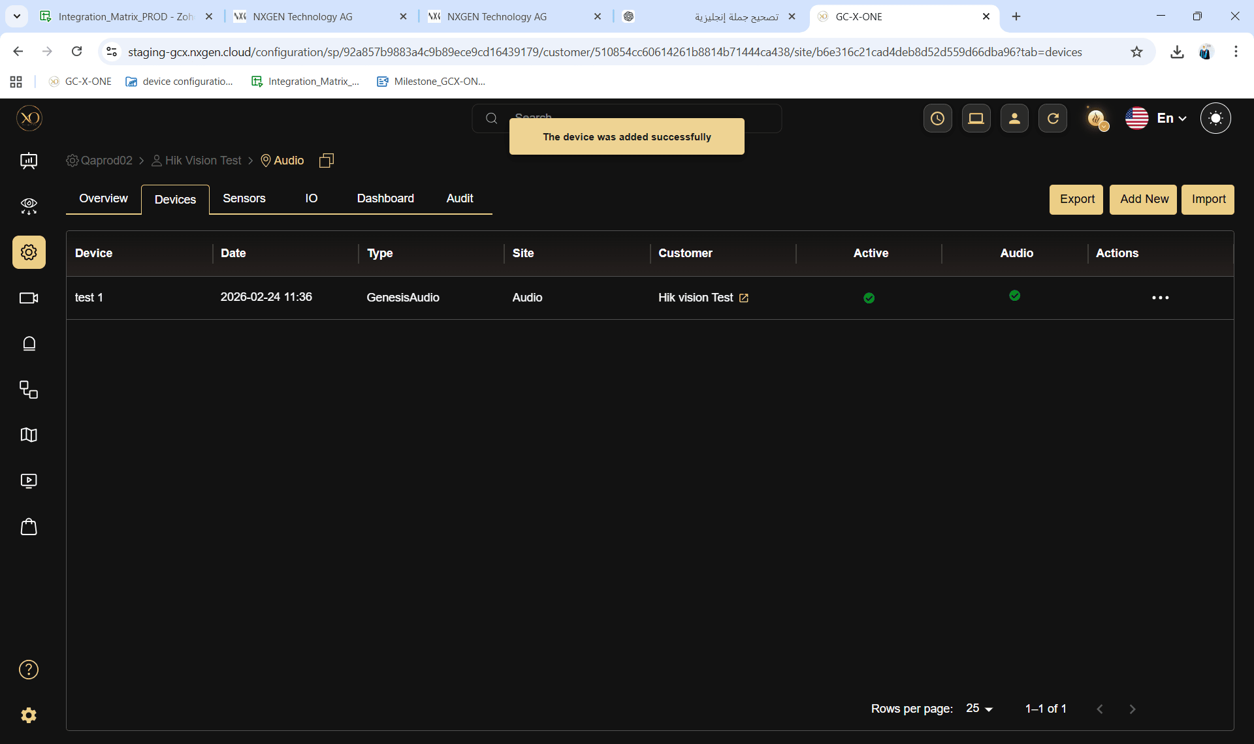

Note: Use the GENESIS Audio device credentials to configure the IP speaker.

2. Initiate a GENESIS Audio Call from Salvo

Step 1: Log in to GCX-ONE.
Step 2: Click the Configuration menu.


Step 3: Select the site and right-click to Expand the site
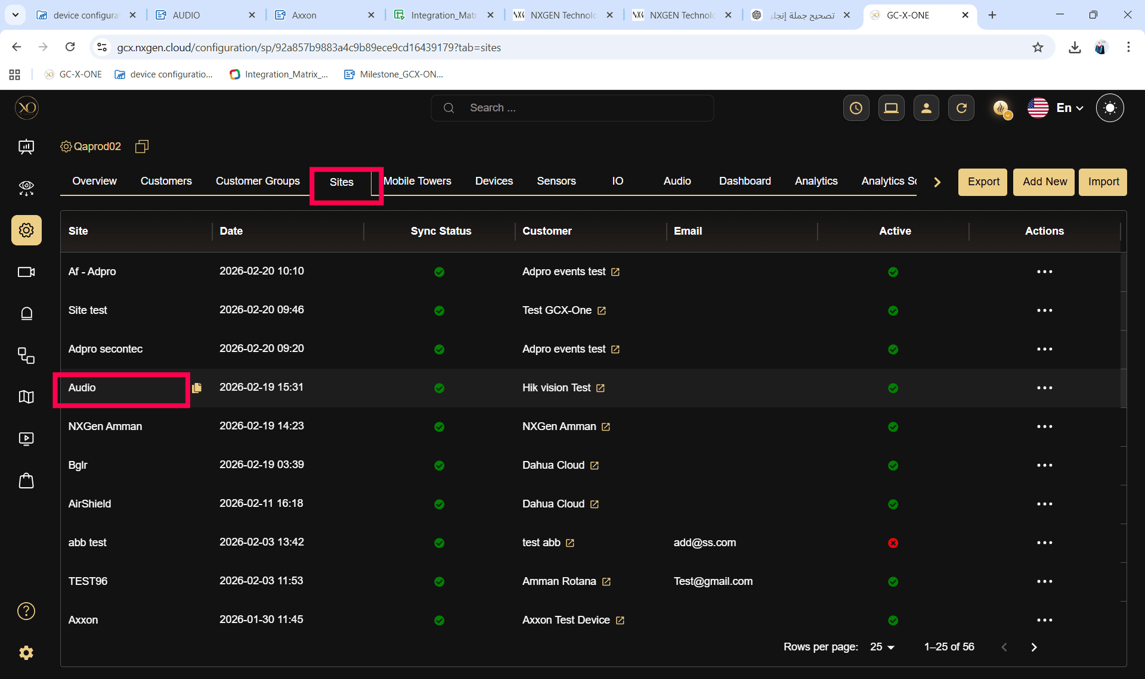
Step 4: Navigate to the Devices tab.
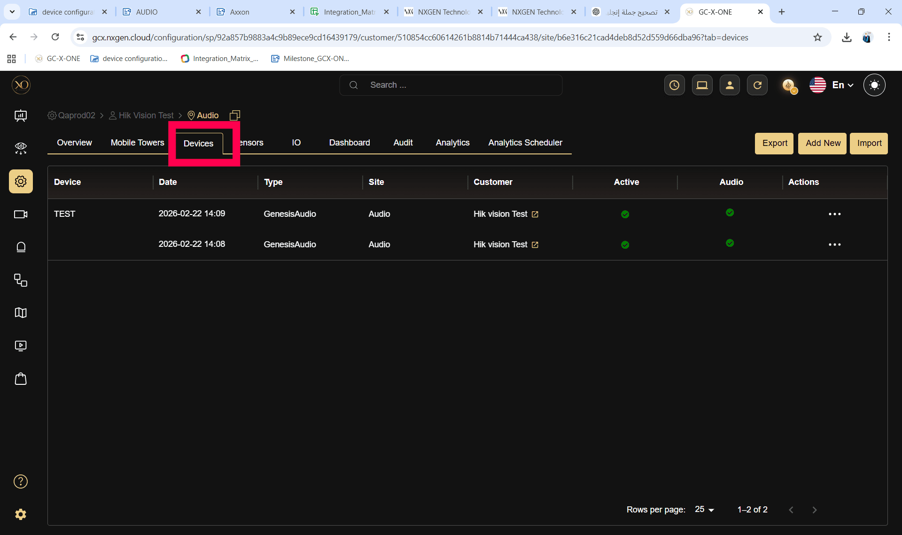

Step 5: Verify that the added GENESIS Audio device is active

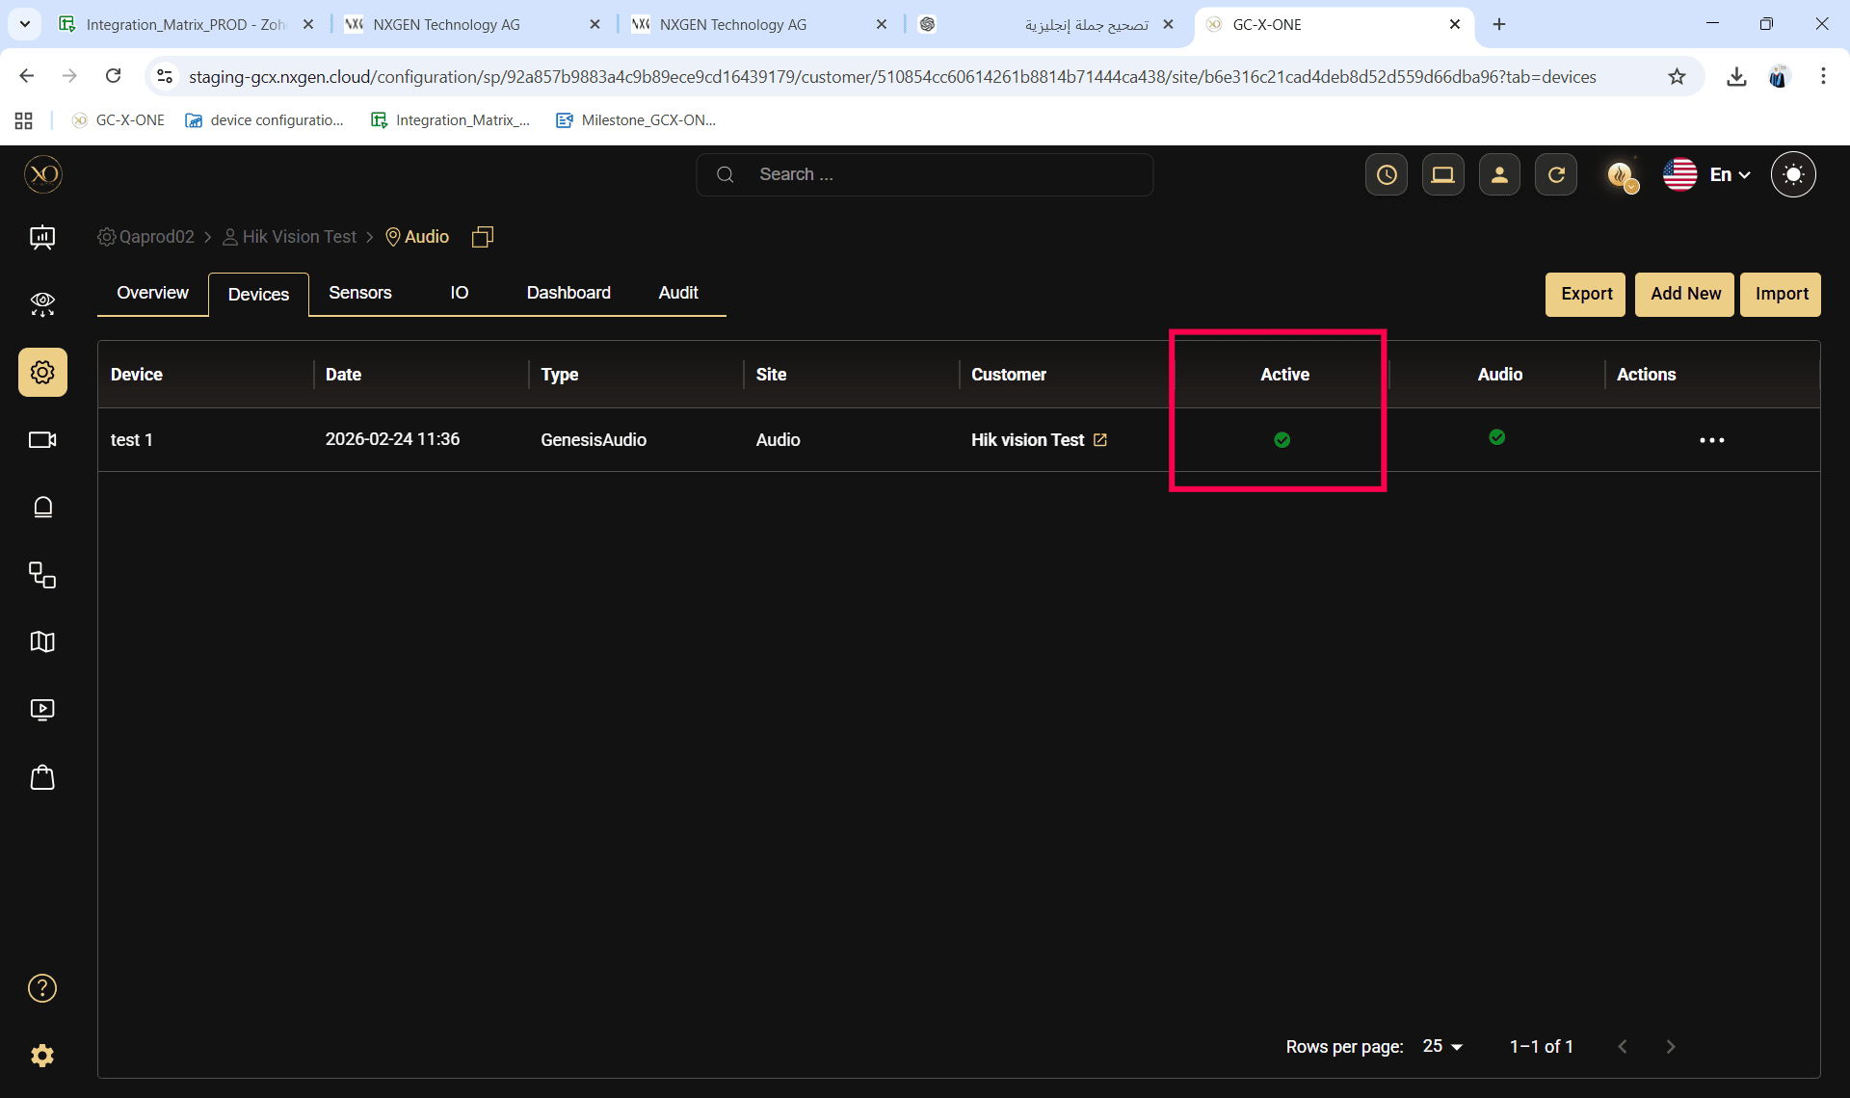

Step 6: Navigate to the Video Viewer (Salvo) application.
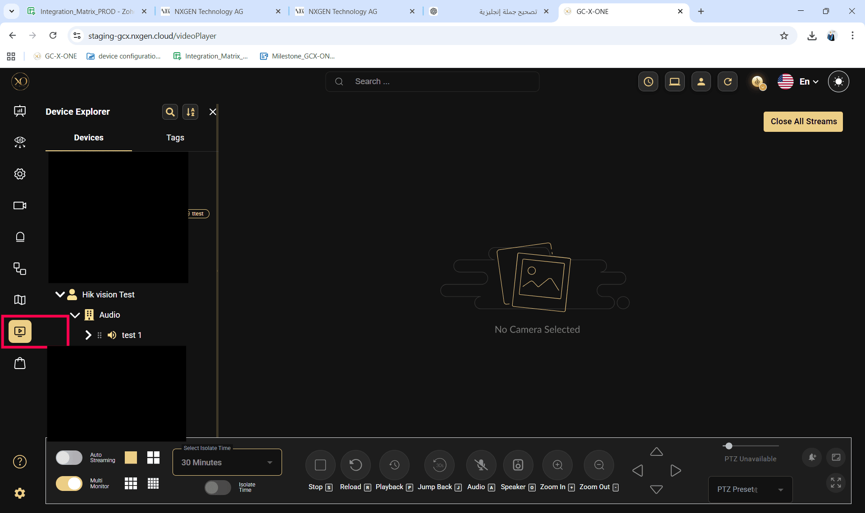
Step 7: Select the site in the tree view and expand it.
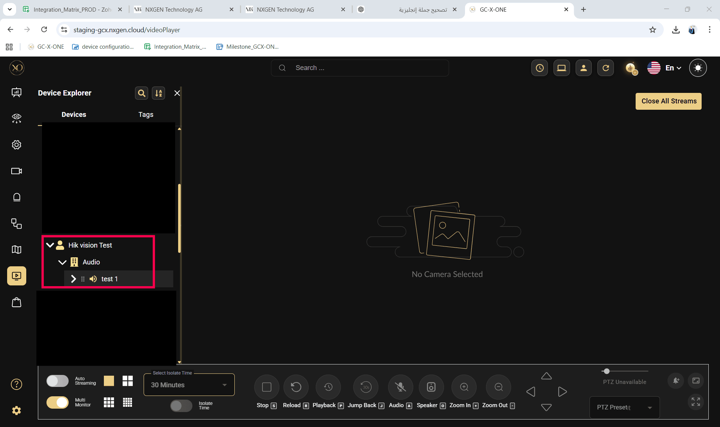
Step 8: Verify that the GENESIS Audio device is listed under the selected site.


Step 9: Drag and drop a sensor from the site into the Video Viewer (Salvo) .
Step 10: Verify that the microphone icon is enabled.

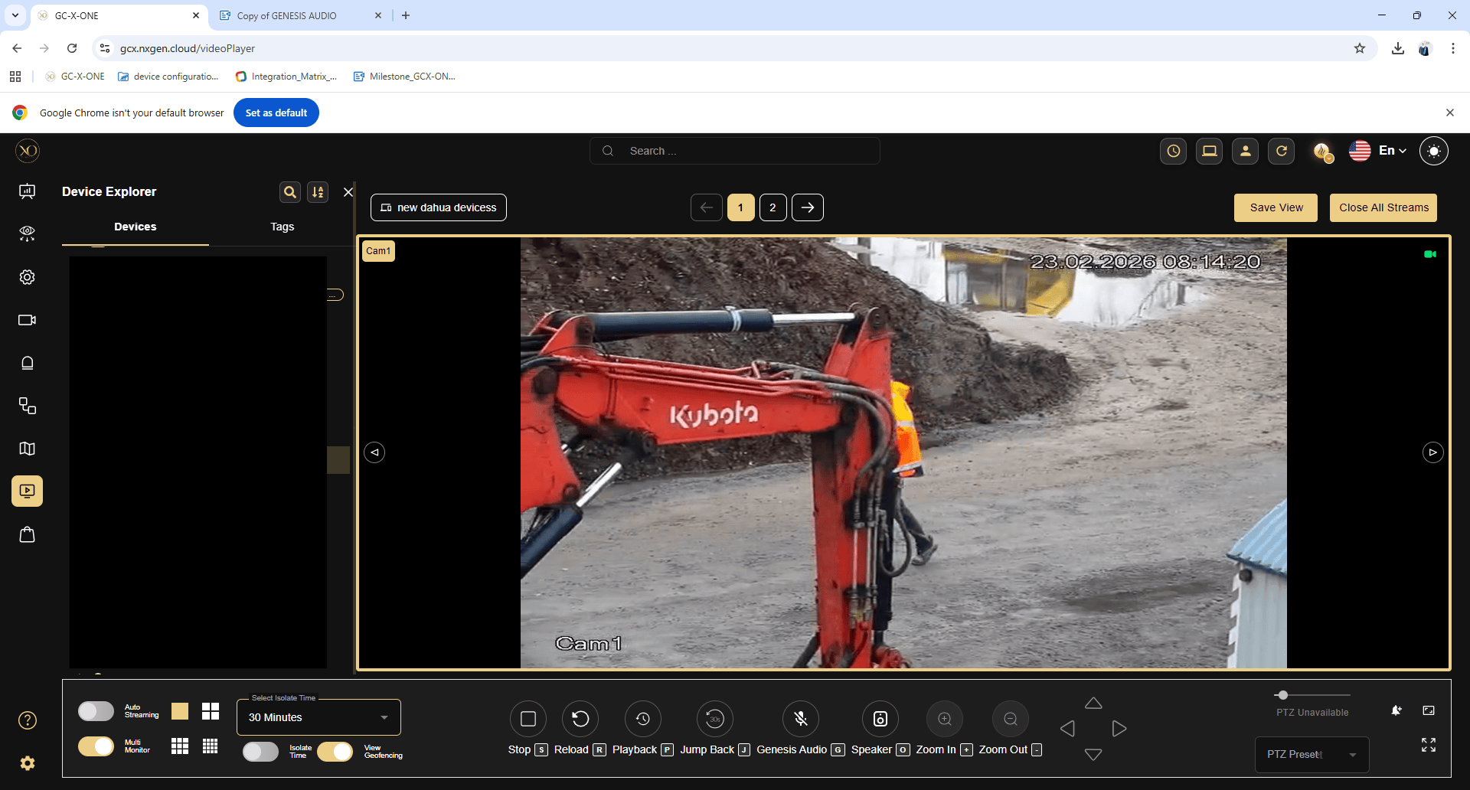

Step 11: Click the microphone icon. An audio call will be initiated.
Step 12: Once the call is connected, the microphone icon will change to indicate that the call is connected.

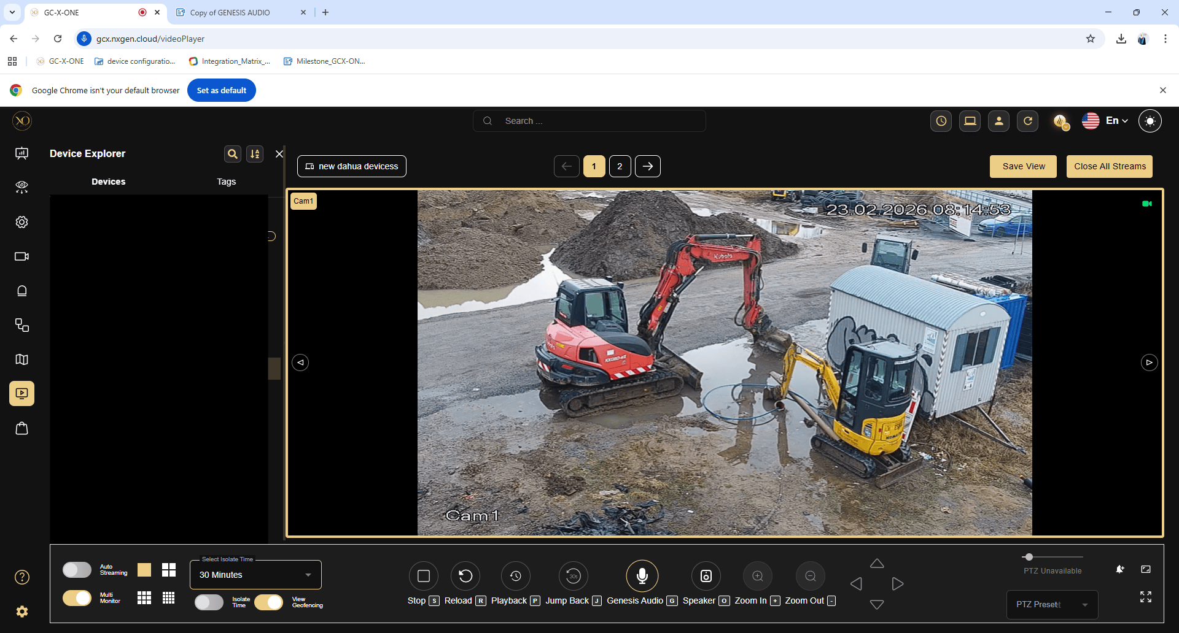

Step 13: Click the microphone icon again to disconnect the call. The microphone icon will change to indicate that the call has been disconnected.
Note: The call will disconnect automatically if the user navigates to another application in GCX-ONE or clicks the refresh button.

Steps to check if the device default audio is working

Important: Local Mode must be enabled to test the device’s default audio.

Step 1: Log in to GCX-ONE.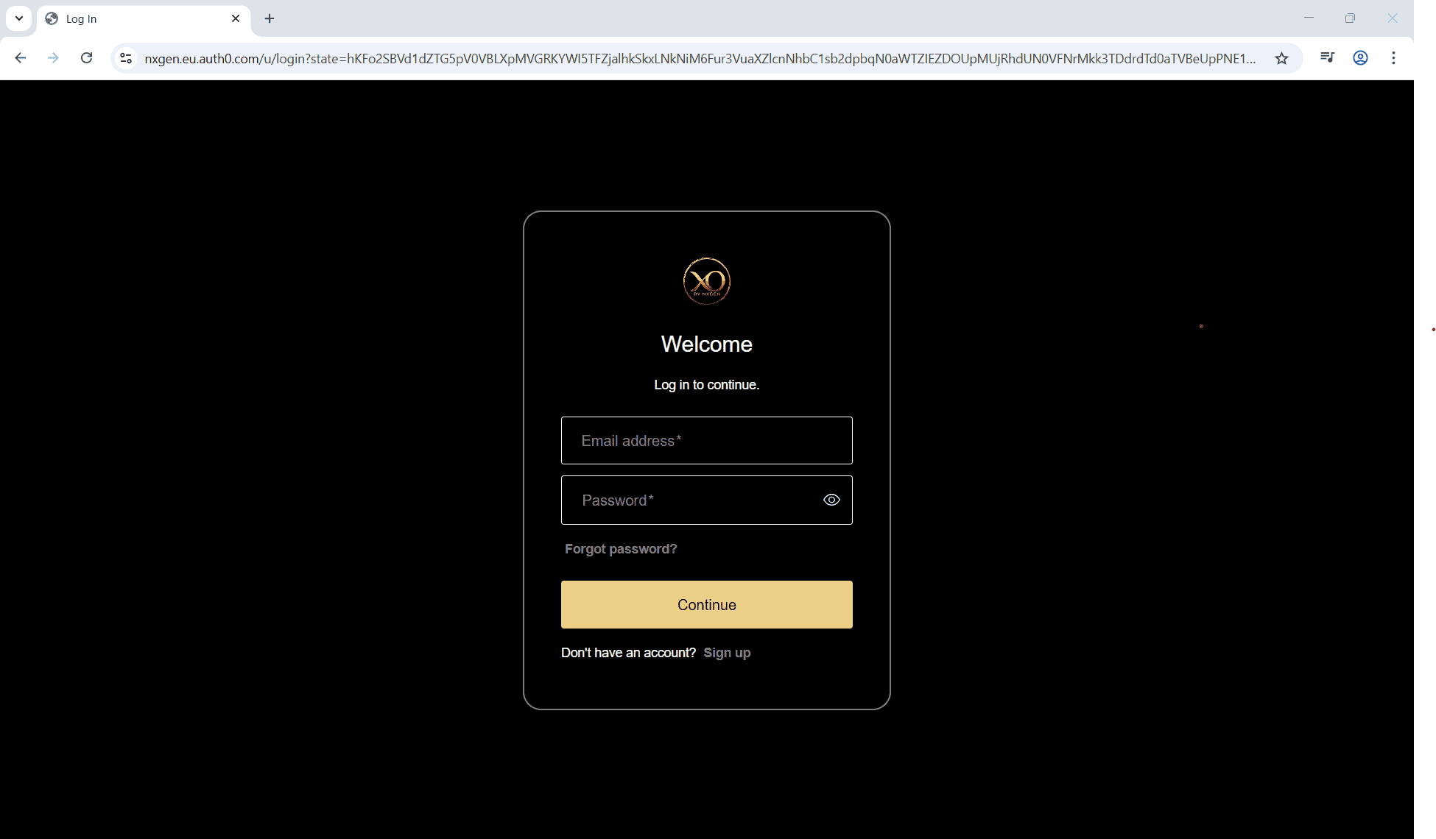
Step 2: Click the Configuration menu.
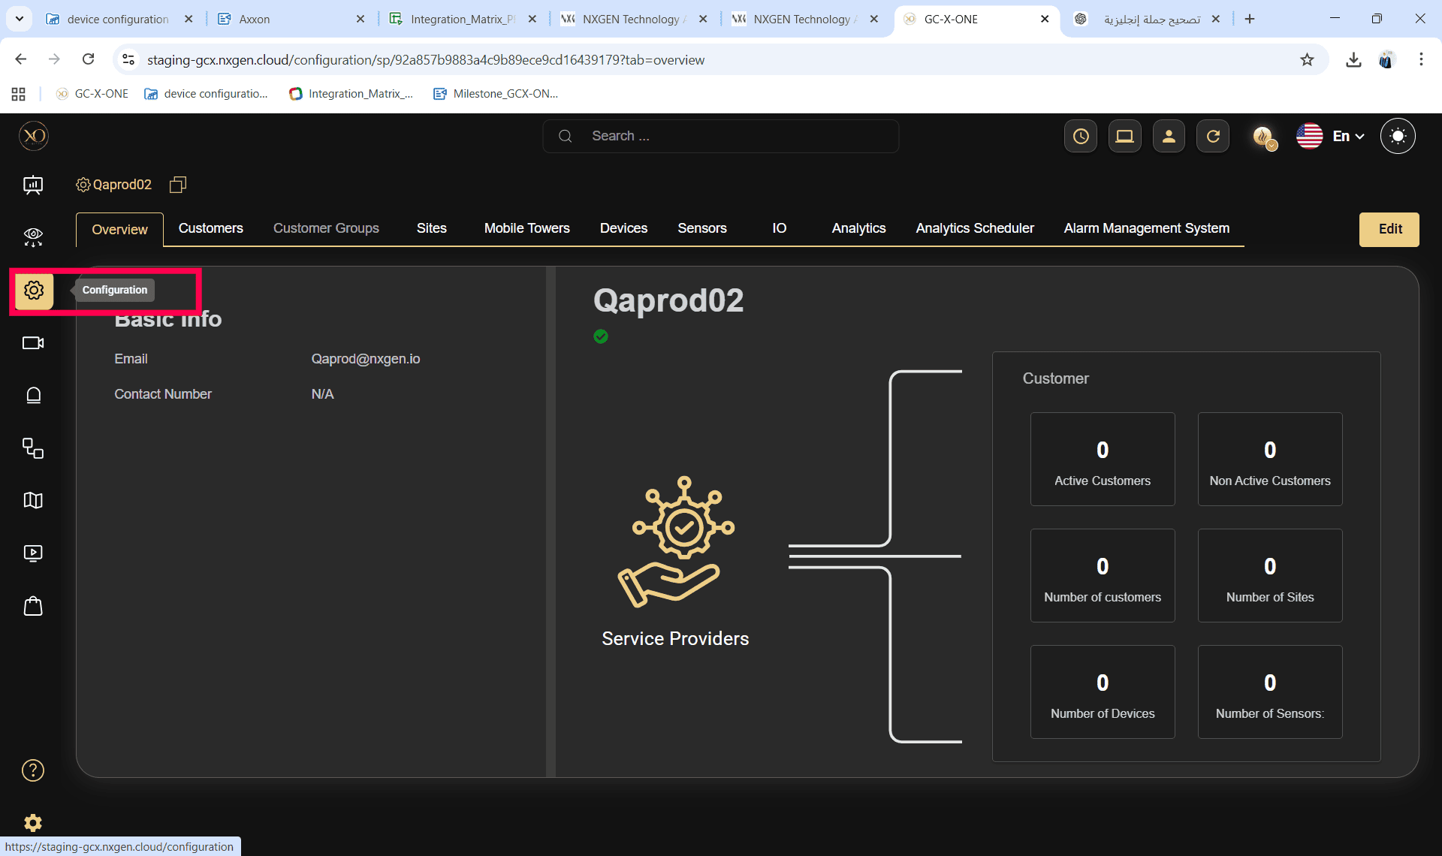

Step 3: Select the site and expand it.
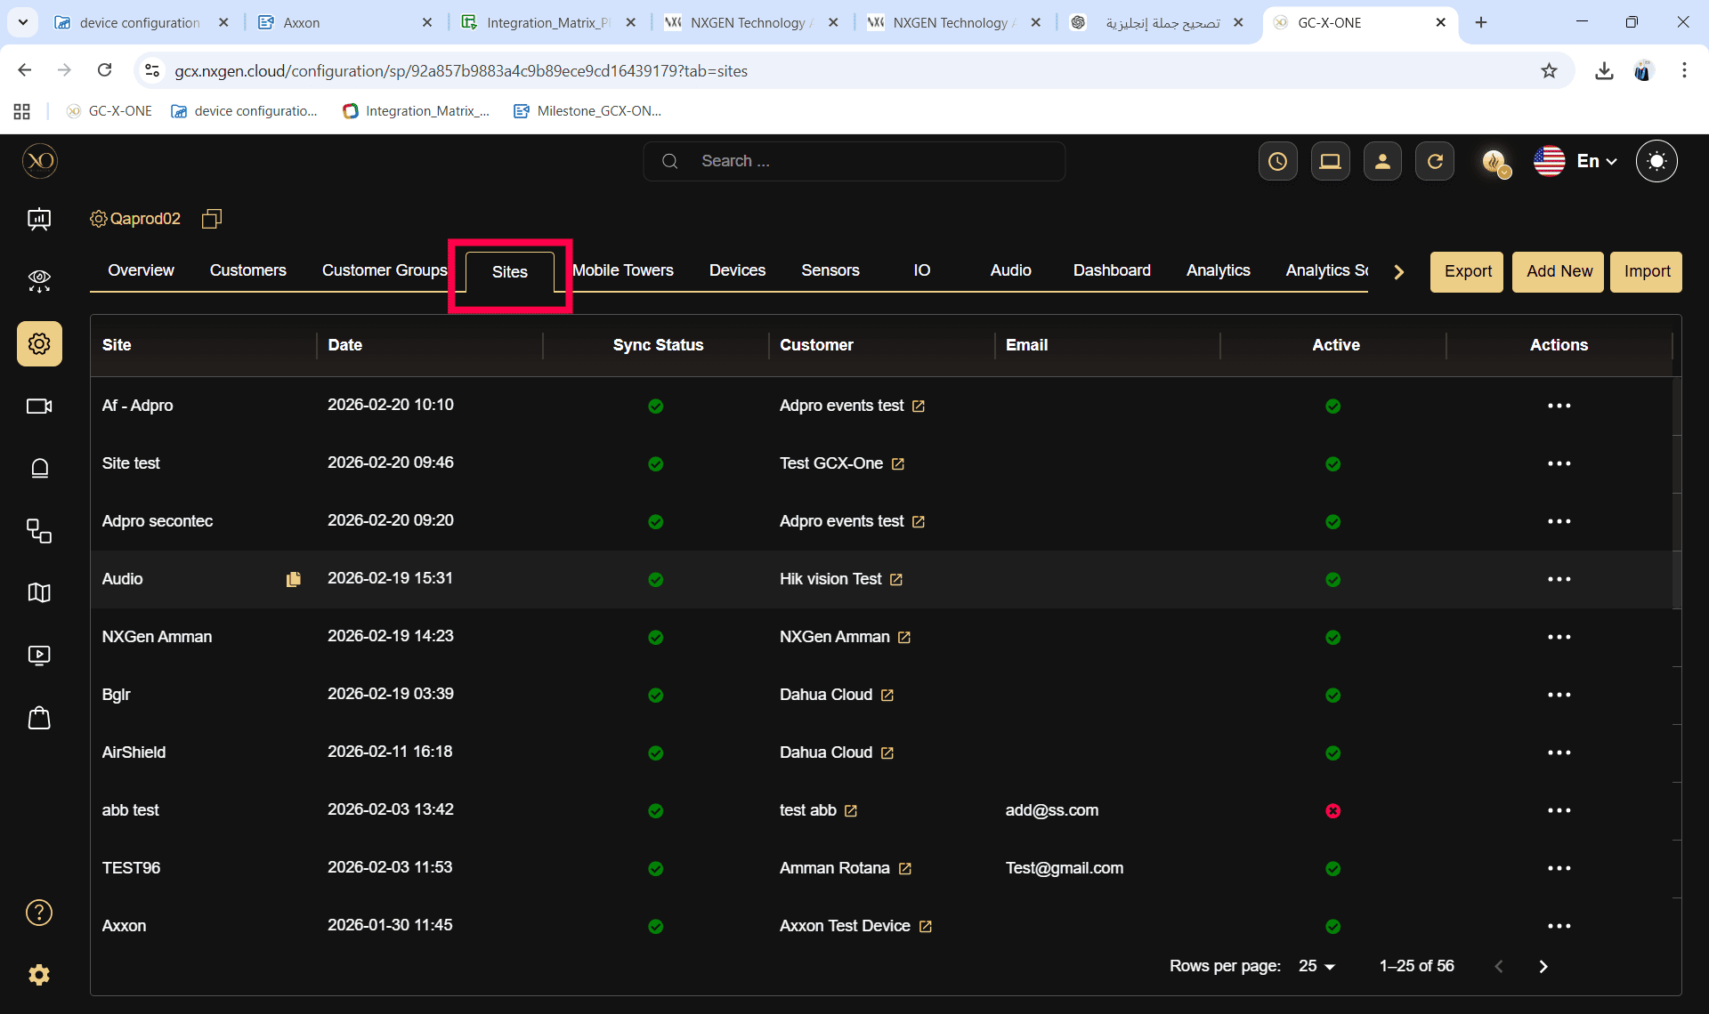
Step 4: Navigate to the Devices tab.
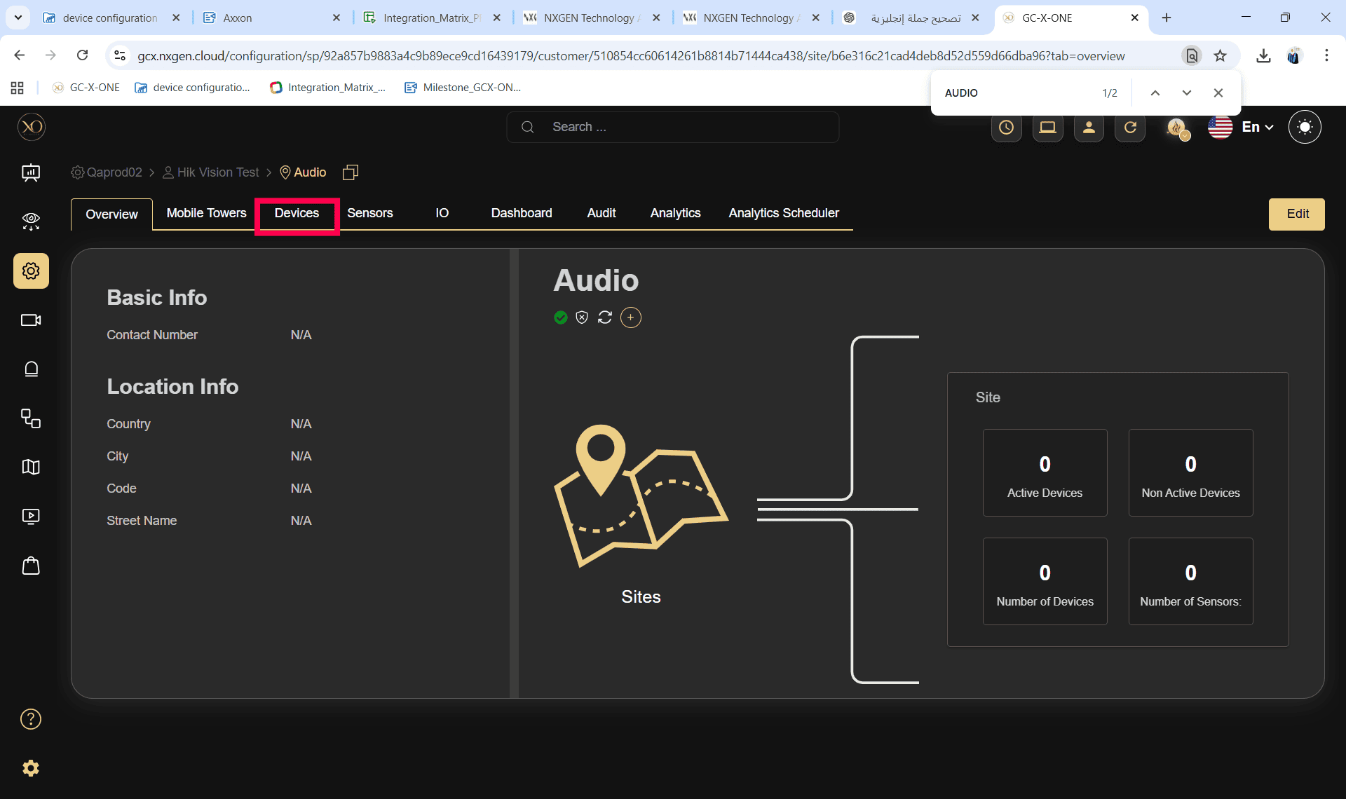

Step 5: Verify that the device is active.
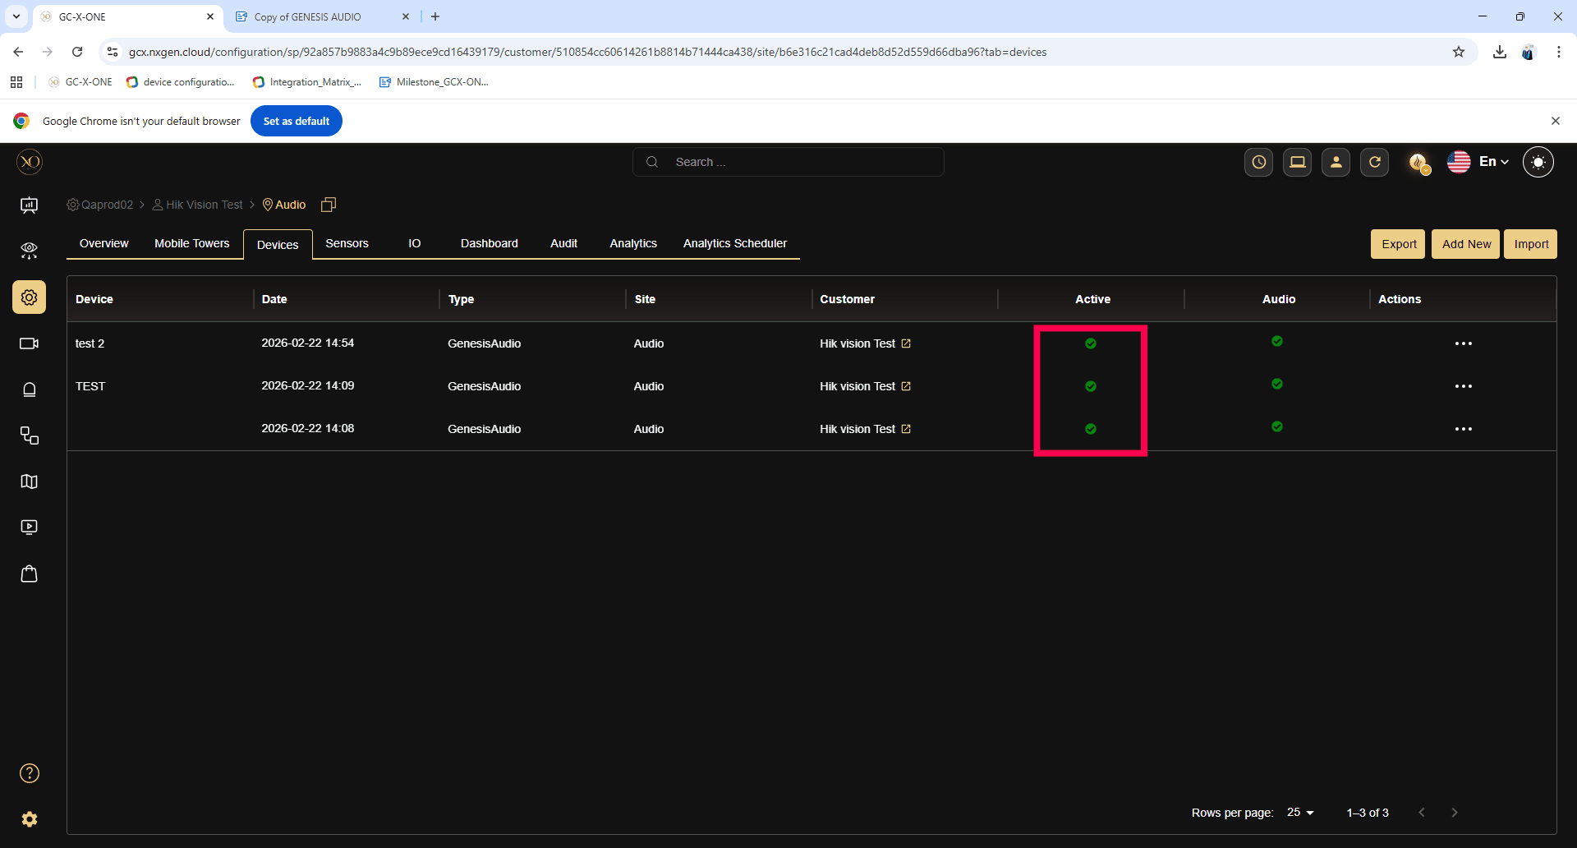

Step 6: Click on the sensors under the device.
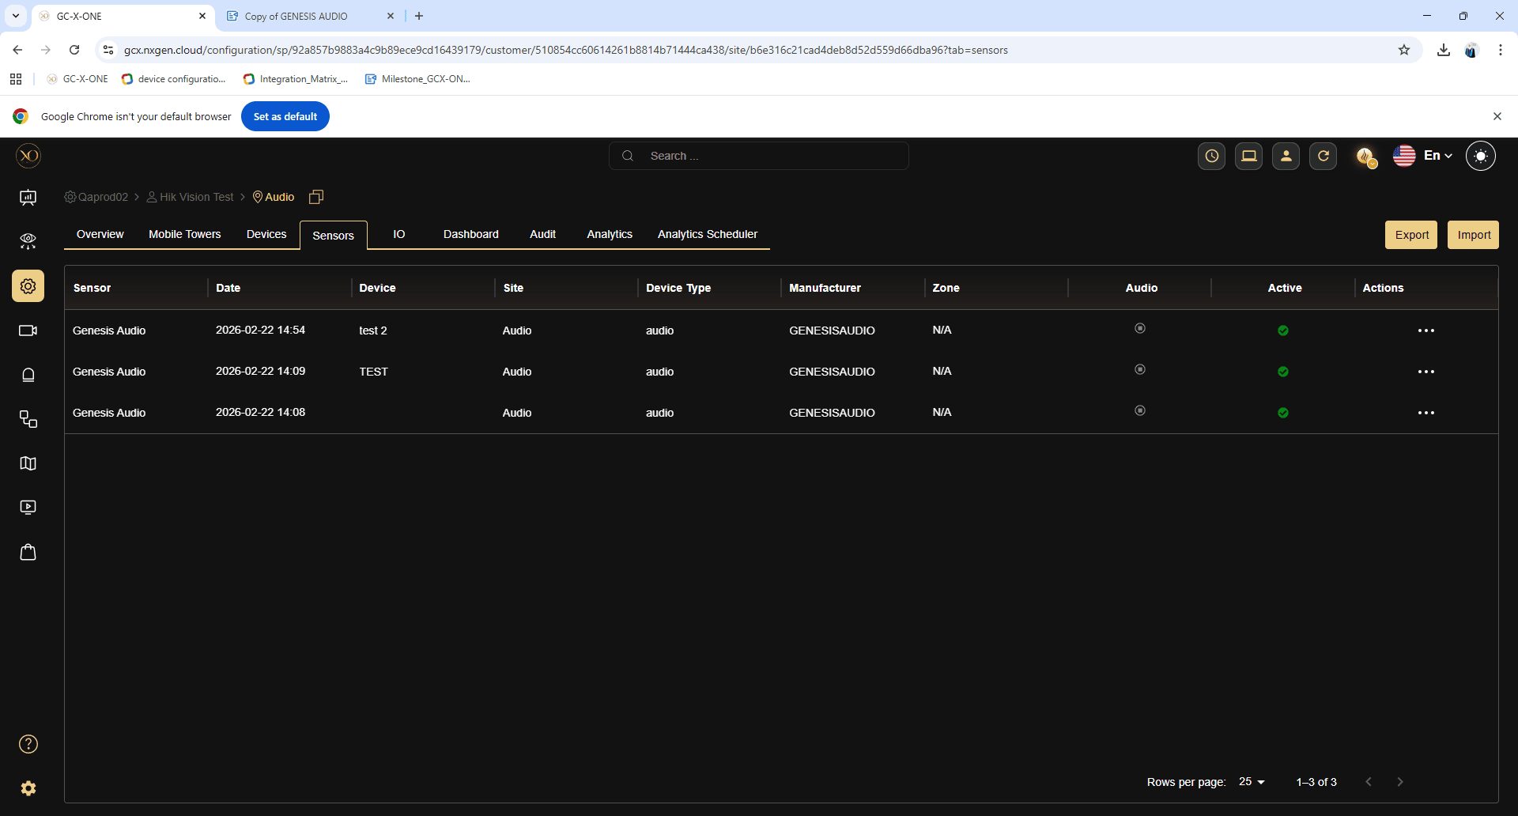

Step 7: Verify that the sensor is active.

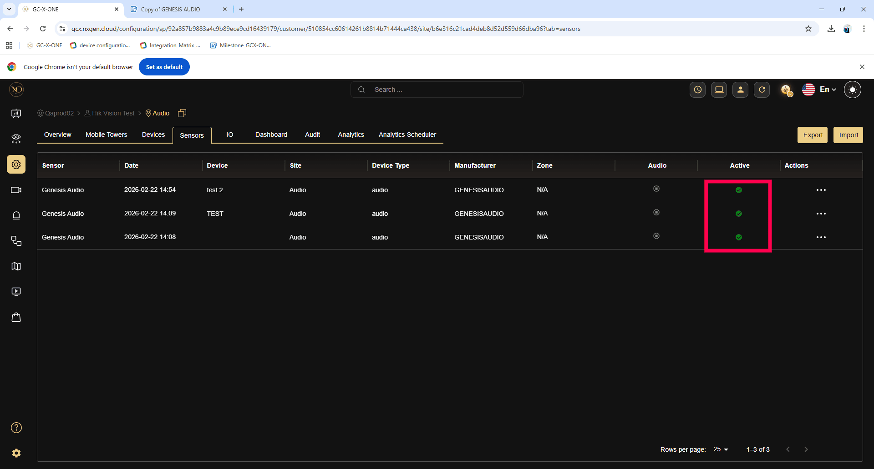

Step 8: Navigate to the Video Viewer (Salvo) application.
Step 9: Select the site and right-click to choose Expand All.
Step 10: Ensure that there is no active GENESIS Audio device under the site. If present, deactivate it to test default audio.

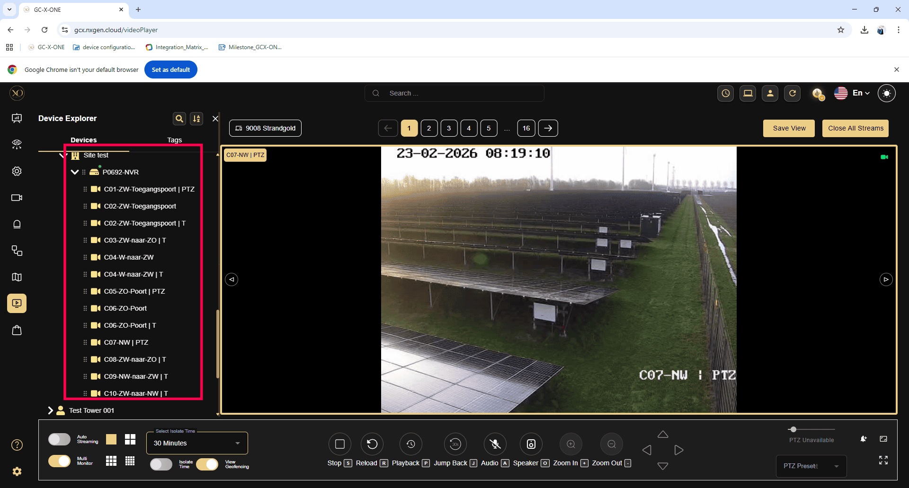

Step 11: Drag and drop a sensor into the Video Viewer (Salvo).
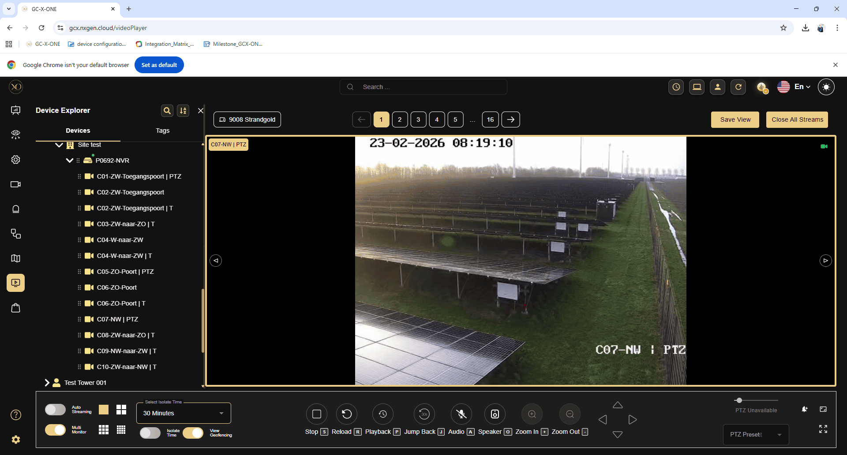
Step 12: Verify that the microphone icon is enabled.
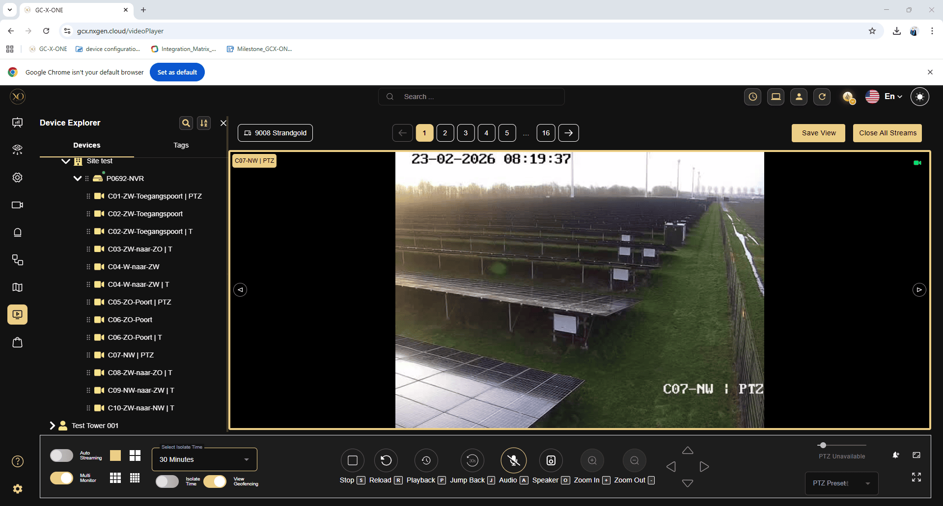

Step 13: Click the microphone icon. The call will be initiated using the device’s default audio.
Step 14: The microphone icon will change to indicate that the call is connected.

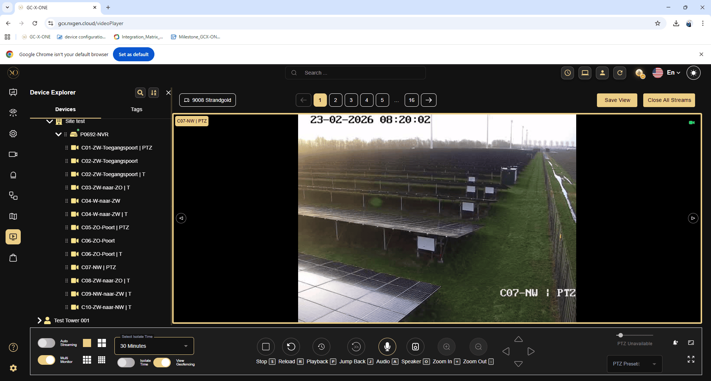

Step 15: Click the microphone icon again to disconnect the call. The microphone icon will change to indicate that the call has been disconnected.
Note: The call will be disconnected automatically if the user navigates to another application in GCX-ONE or clicks the refresh button.

Release Note 1.1.14

GENESIS Audio – SIP Server Support

Feature
Support for Custom SIP URL configuration.

Description
The Custom SIP URL can include a combination of:
- Username
- Password
- IP Address
- Port Number

Steps to Add GENESIS Audio device with Custom SIP URL:

Step 1: Log in to GCX-ONE.
Step 2: Click the Configuration menu.



Step 3: Select the site under which the GENESIS Audio device needs to be added.


Step 4: Navigate to the Devices tab.


Step 5: Click the Add button.


Step 6: Select the device type as GENESIS Audio.


Step 7: Enable the SIP Server checkbox
Step 8: Edit the name if required
Step 9: Enter the Custom SIP URL in the provided field

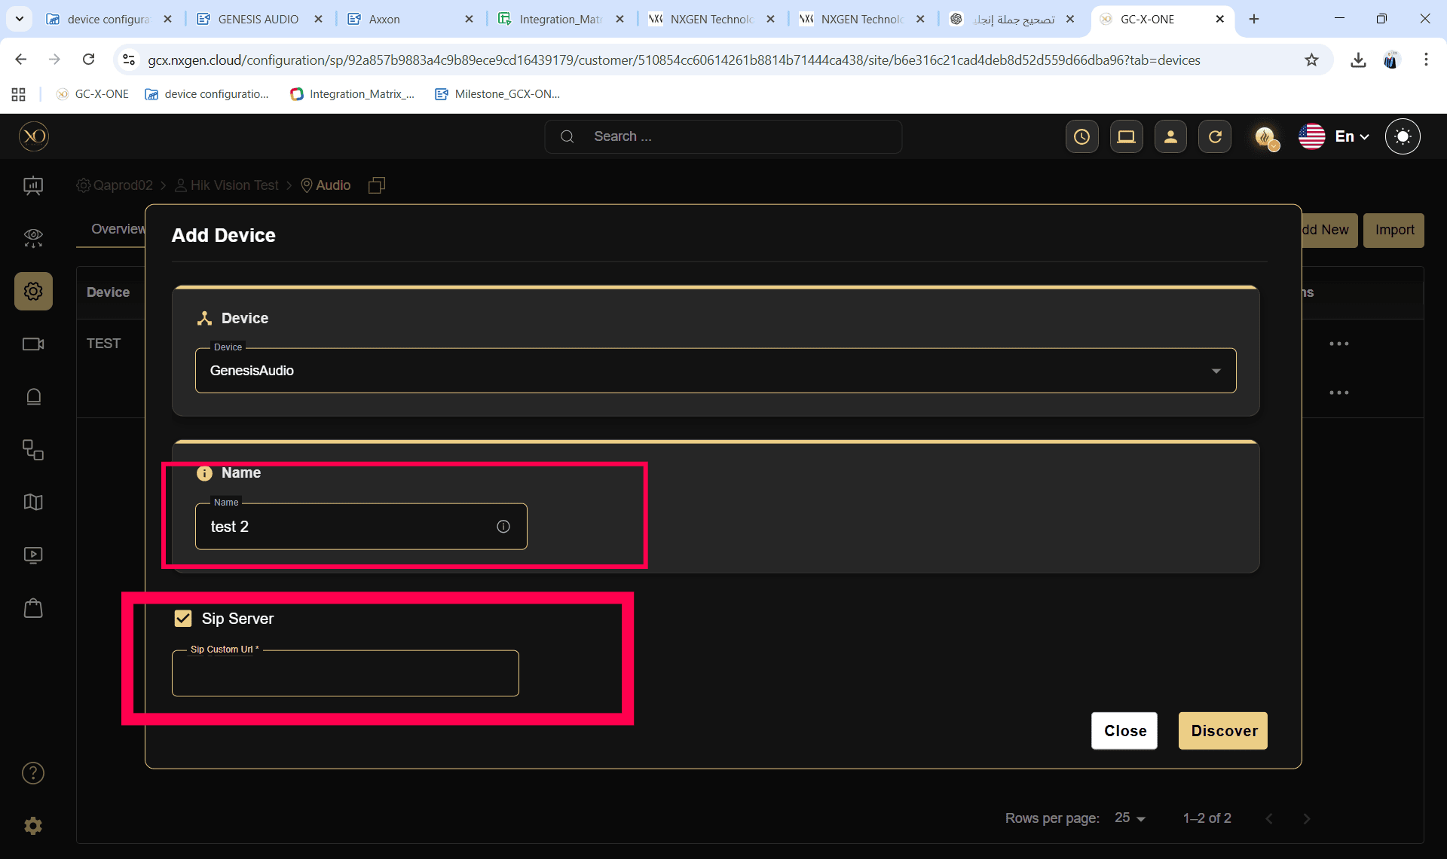

Step 10: Click the Discover button.
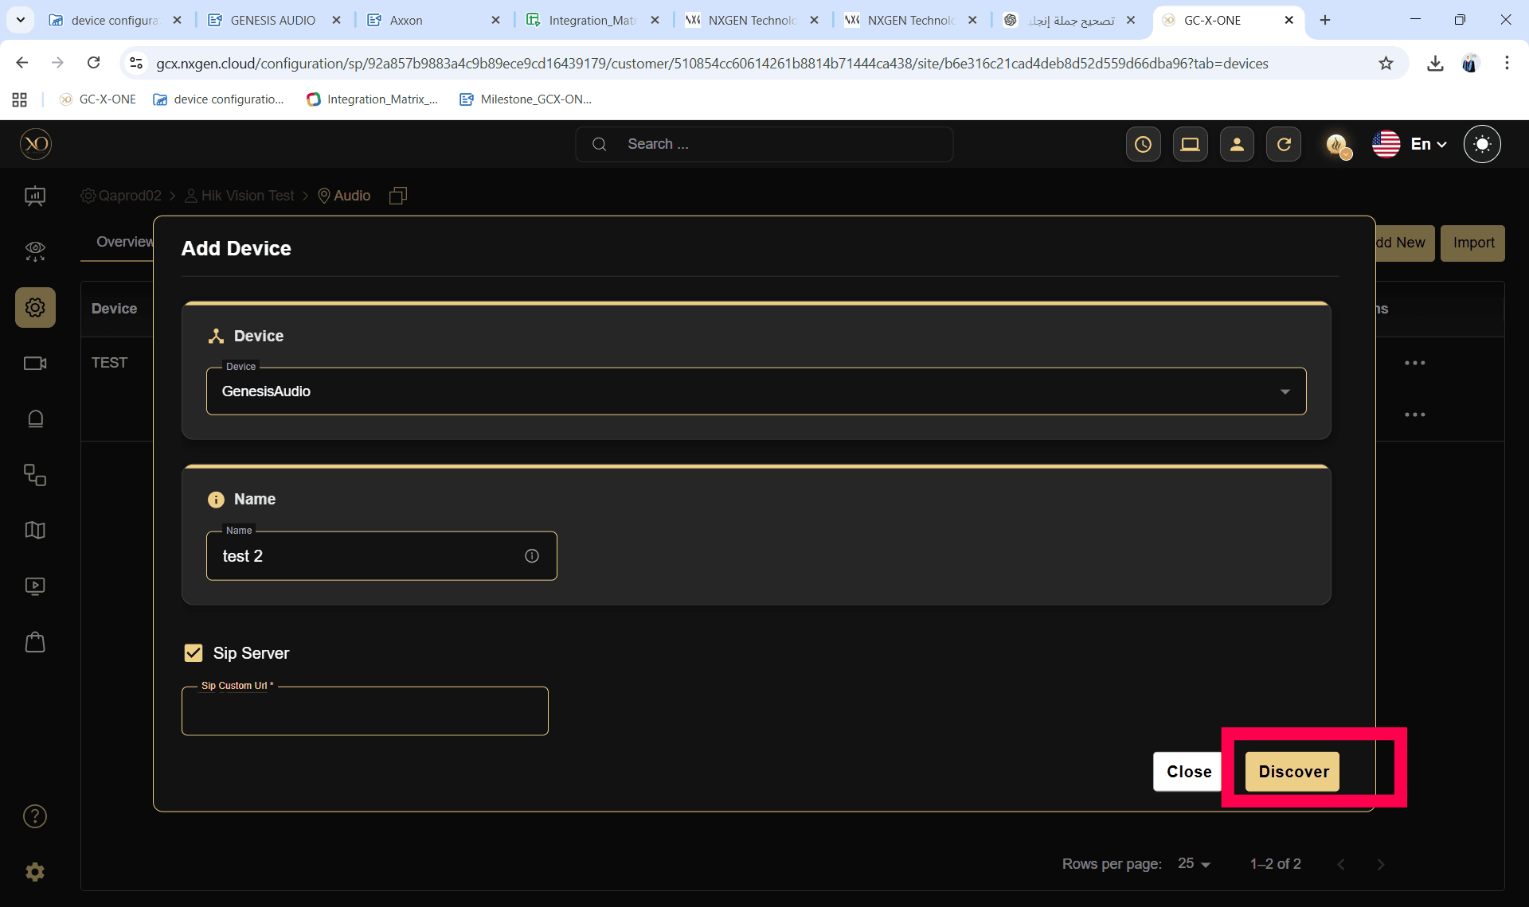

Step 11: Click the Save button.

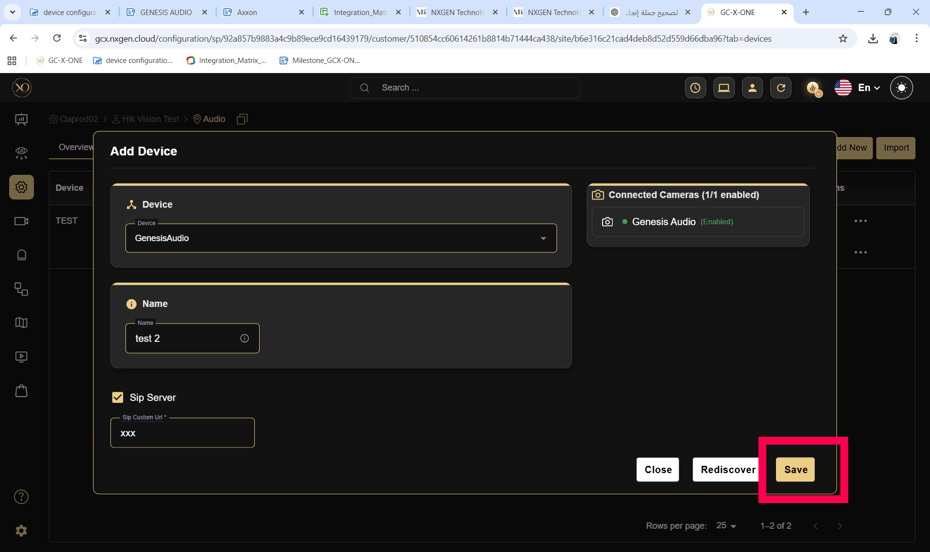

Step 12: The GENESIS Audio device with the Custom SIP URL will be added successfully, and a success popup message (“The device was added successfully”) will be displayed.

